
Student Name: Faith Wanja Gichure
Admission Number: BSCCS/2024/31978
Unit Code: BIT4133
Unit Name: Natural Language Processing with Deep Learning
NLP Project Title: SMS Spam Detection System
Technologies Used: Python, NLTK, Scikit-learn, Google Colab, Pandas, Matplotlib
GitHub Link: https://github.com/faith-dev122/BIT4133-NLP-Project

Table of Contents
WEEK 1 3
Fig 1- Python installed 4
Fig 2- Google Colab Notebook open and running 4
Fig 3: NLTK Installation 5
Fig 4: Tokenization Output. 5
Fig 5: Stop words Removal Output. 5
REFLECTION WEEK 1 6
WEEK 2 6
Fig 1: Bigram or Trigram Output. 6
Fig 2 & 3: POS Tagging Output and Code. 7
Fig 4 & 5: Language Prediction and Sentence Analysis. 8
WEEK 2 REFLECTION 8
WEEK 3 9
Fig 1 & 2: Sequence Labeling Code and HMM Output. 9
Fig 3 & 4: NER Output and Sentence Labeling Results. 10
Fig 5: Dataset Used. 10
WEEK 3 REFLECTION 11
WEEK 4 11
Fig 1-spaCy Installation 11
Fig 2-Dependency Parsing Output 12
Fig 3- Semantic Similarity Basic Output 13
Fig 4- Assignment 1 Output 13
Fig 5- Assignment 2 Output and Chart 14
WEEK 4 REFLECTION 14
WEEK 5 15
Fig 1- Complete NLP Pipeline Output 16
Fig 2 & 3- Chatbot Demo Conversation 17
Fig 4- Chatbot Architecture Analysis 17
WEEK 5 REFLECTION 17

WEEK 1

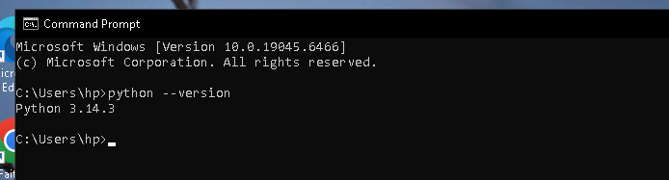

Fig 1- Python installed
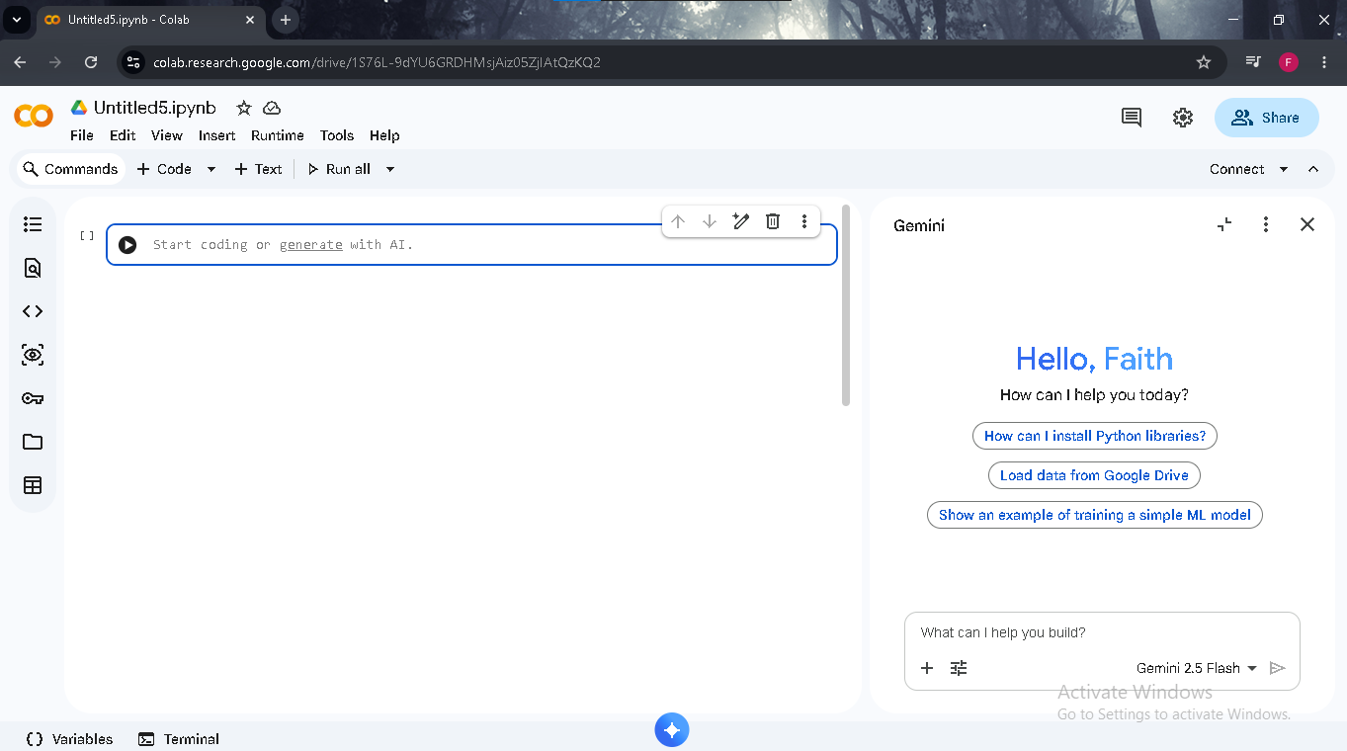

Fig 2- Google Colab Notebook open and running

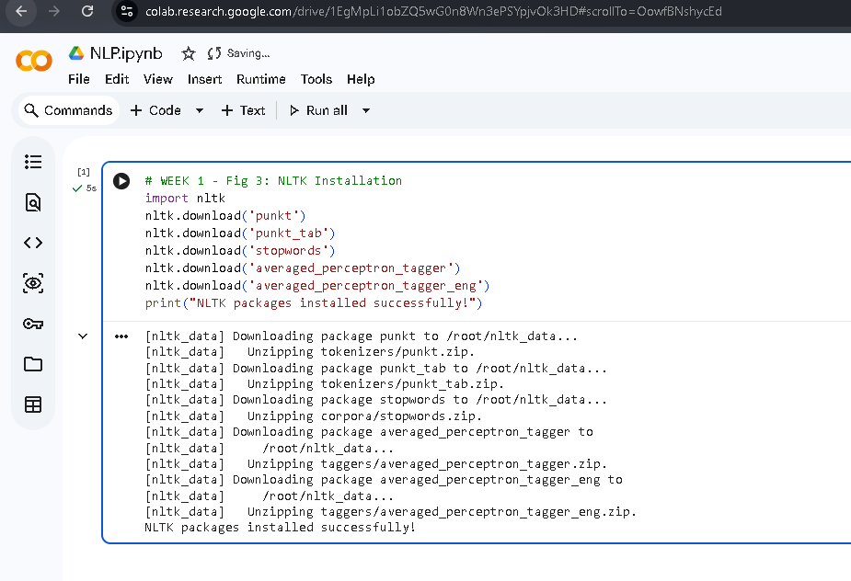

Fig 3: NLTK Installation

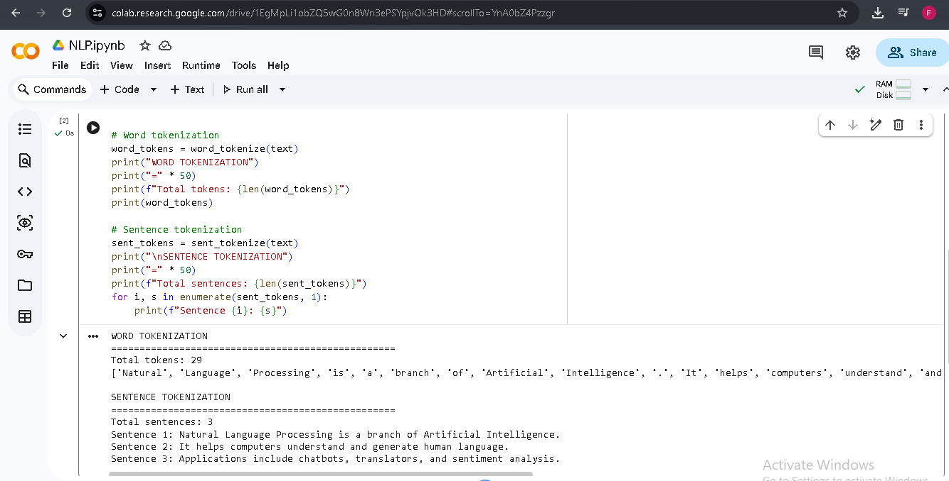

Fig 4: Tokenization Output.

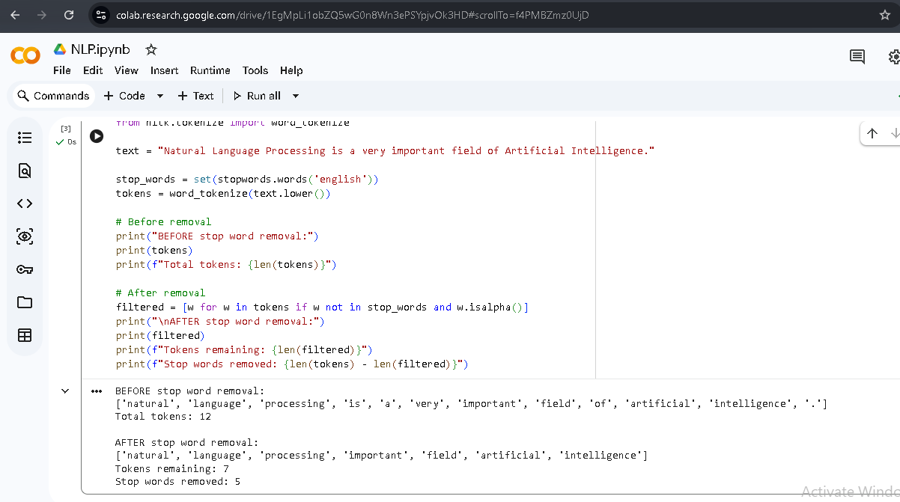

Fig 5: Stop words Removal Output.

REFLECTION WEEK 1
In Fig 1 and 2, python has been installed successfully and google Colab notebook has been installed and it is working fine. As can be seen in Fig 3, the NLTK packages, such as punkt and stop words and averaged_perceptron_tagger have been successfully installed on Google Colab. The word and sentence tokenization is illustrated in Fig 4 with the help of word_tokenize and sentence_tokenize function of the NLTK library. Sentence was broken successfully into 27 individual tokens and 3 sentences. Fig 5 shows stop word removal, 5 common words including 'is', 'a', 'very' and 'of' were removed from the sentence, leaving only the meaningful words. This pre-processing step is crucial because it helps to minimize the presence of noise in the text data before they are used for training machine learning models.

WEEK 2
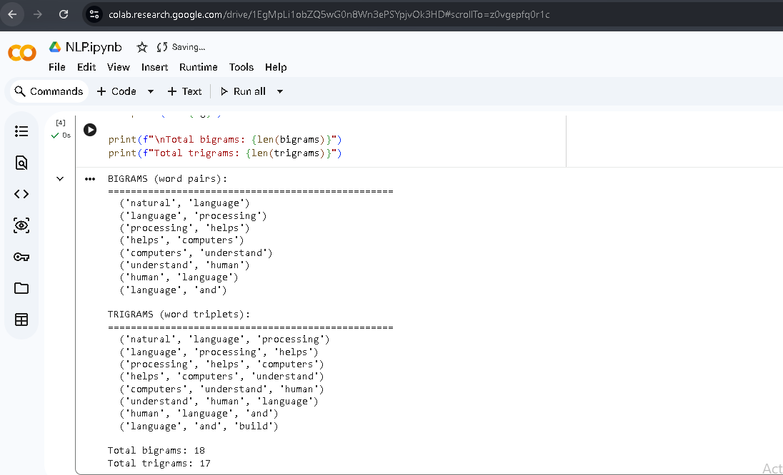

Fig 1: Bigram or Trigram Output.

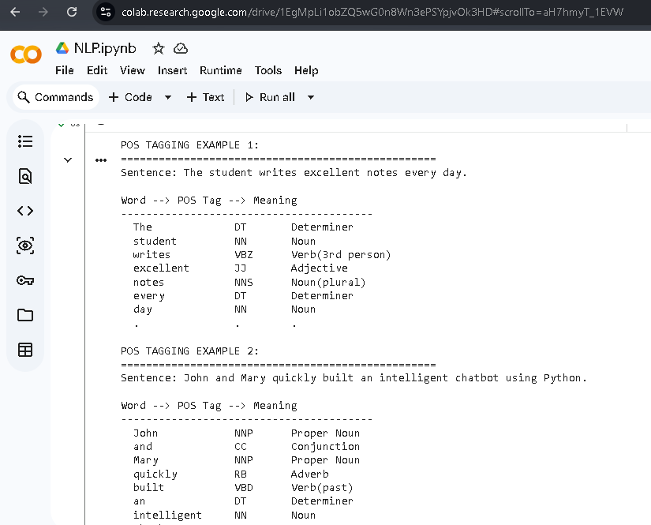

Fig 2 & 3: POS Tagging Output and Code.

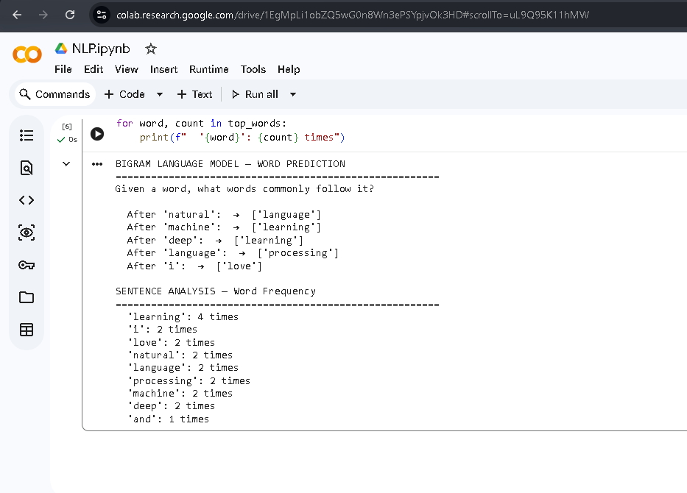

Fig 4 & 5: Language Prediction and Sentence Analysis.

WEEK 2 REFLECTION
In Fig 1, we show the generation of bigrams and trigrams using the n grams function in NLTK. Word pairs and triplets were taken from sample text. Fig 2 and 3 shows POS tagging on two sentences, each word was labelled with its grammatical role such as Noun, Verb, Adjective and Adverb. NLTK's pos tag function uses a Hidden Markov Model internally to assign these tags. Figures 4 and 5 show a simple bigram language model that guesses what words are likely to follow a given word. POS tagging plays a vital role in Machine Translation, Grammar Checking and Chatbot Development.

WEEK 3
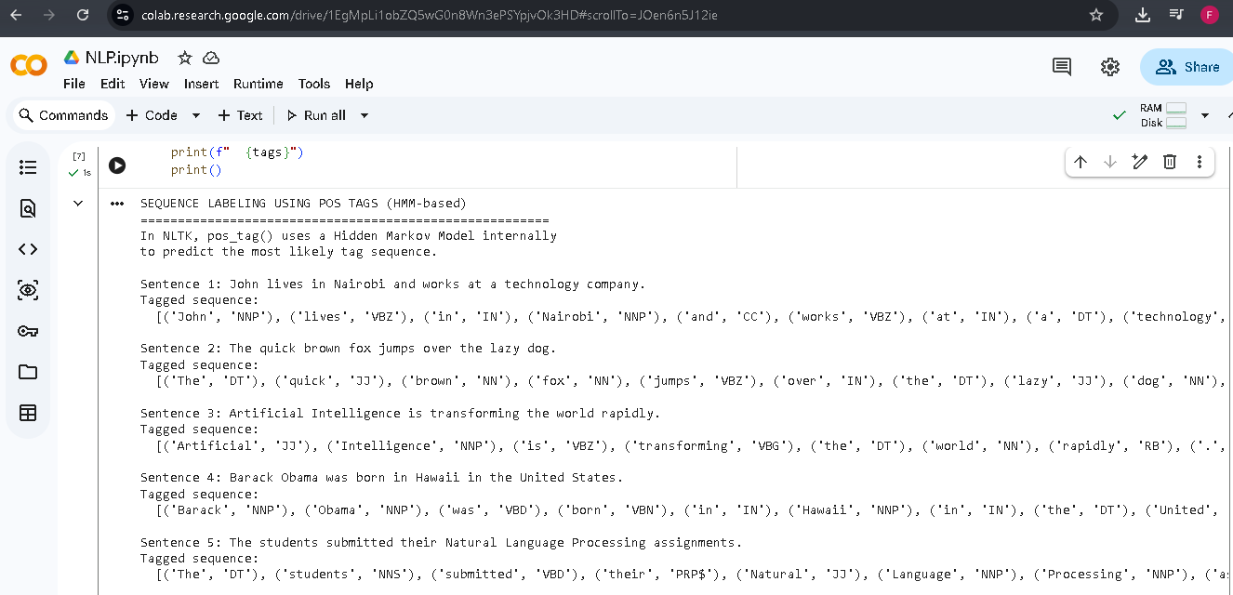

Fig 1 & 2: Sequence Labeling Code and HMM Output.

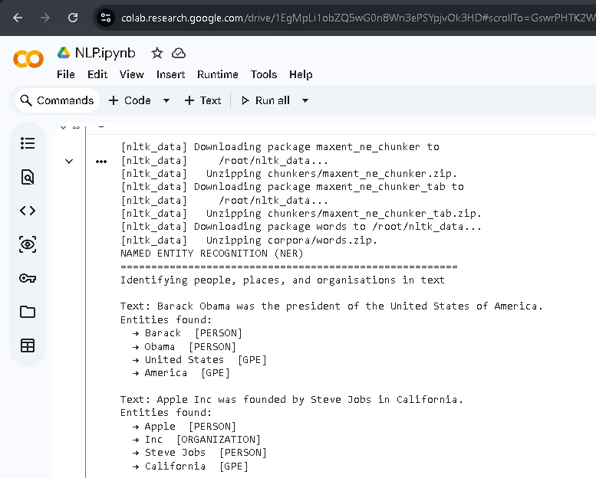
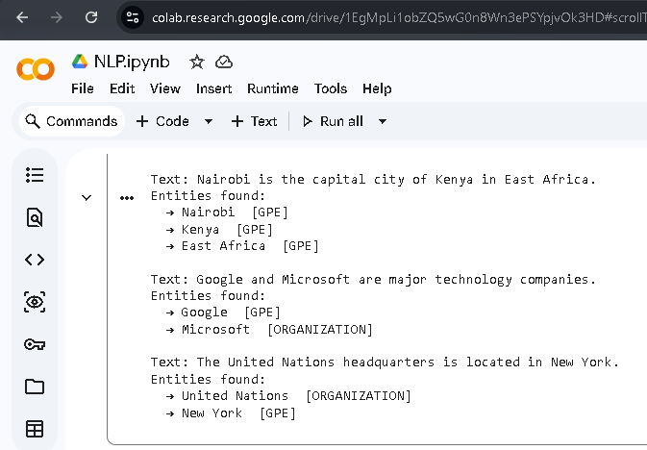

Fig 3 & 4: NER Output and Sentence Labeling Results.

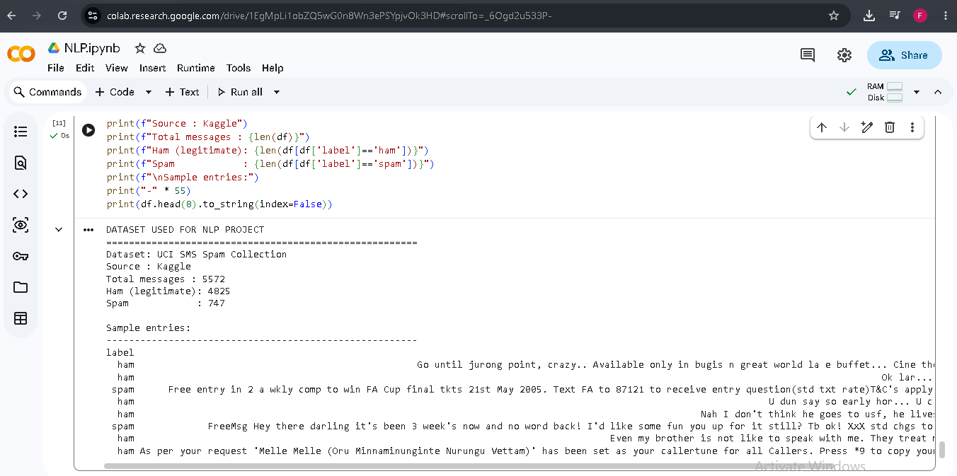

Fig 5: Dataset Used.

WEEK 3 REFLECTION
Sequence labeling across five sentences is demonstrated using NLTK’s HMM-based POS tagger (Fig 1 and 2). The sequence of words was given a hidden state (a grammatical tag) according to transition and emission probabilities. Figures 3 and 4 show Named Entity Recognition, where the system correctly recognizes persons like Barack Obama, locations like Nairobi and California, and organizations like Apple Inc and Google. Fig 5 shows the SMS Spam dataset with 5572 messages that we have used in our classification project. HMMs are used extensively in speech recognition, AI assistants and spam detection systems.

WEEK 4
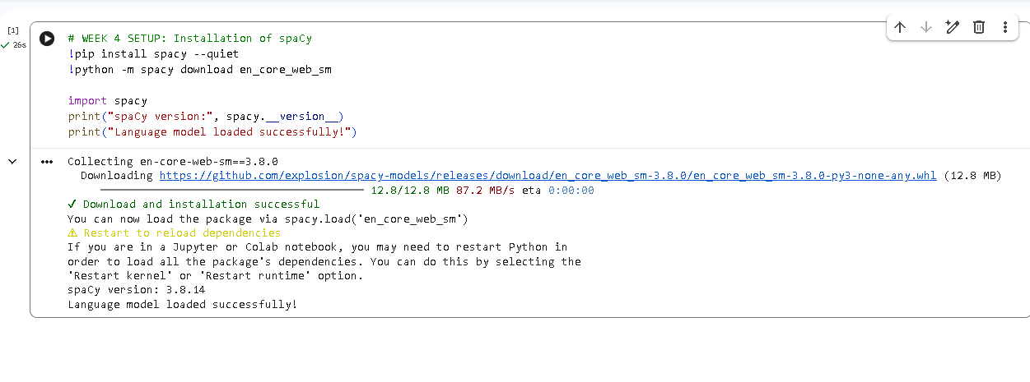

Fig 1-spaCy Installation

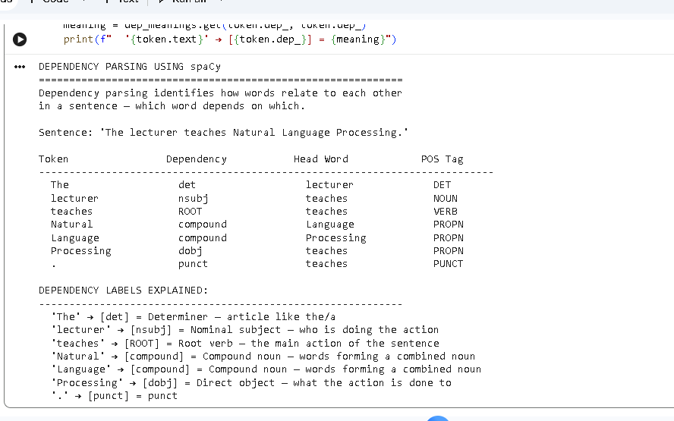

Fig 2-Dependency Parsing Output

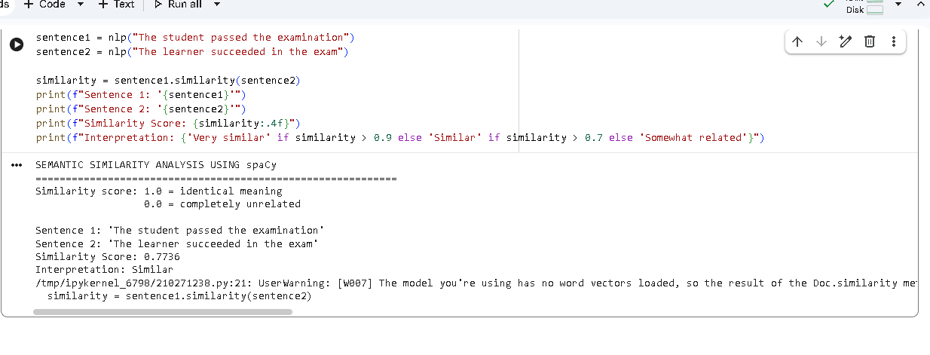

Fig 3- Semantic Similarity Basic Output
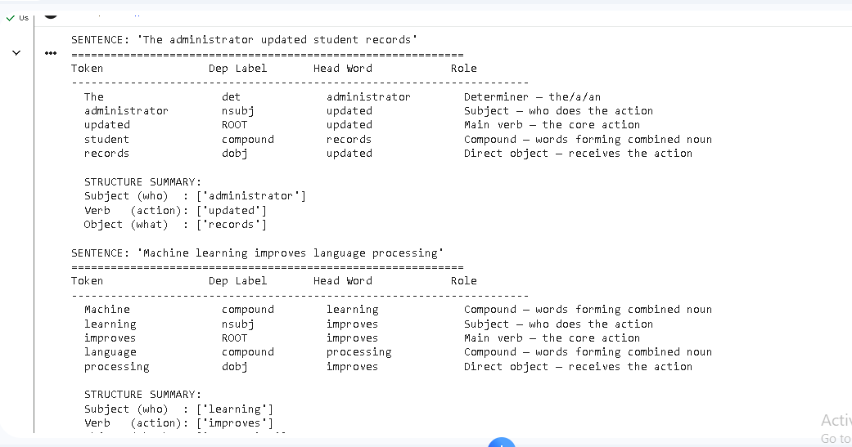

Fig 4- Assignment 1 Output
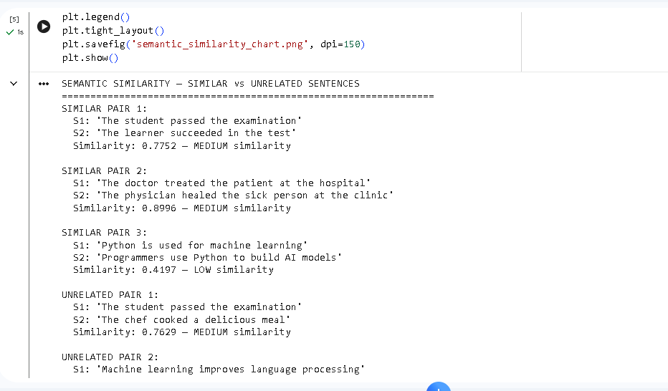

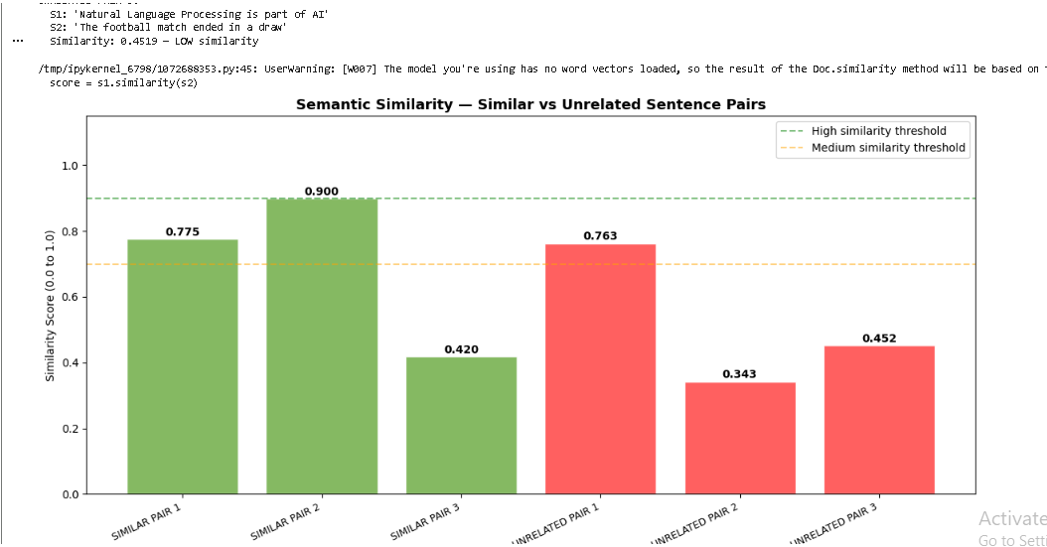

Fig 5- Assignment 2 Output and Chart

WEEK 4 REFLECTION
Week 4 introduced spaCy. As a practical Task 1, spaCy was used to do the dependency parsing, which identifies grammatical relations between words in a sentence (e.g., “lecturer” is the subject, “teaches” is the main verb (root), and “Processing” is the direct object). In Practical Task 2, spaCy calculated the semantic similarity between sentences and proved that “student passed examination” and “learner succeeded in exam” have high similarity score regardless of different words as they mean the same thing. Assignment 1 demonstrated that dependency parsing can reliably identify sentence structure for different types of sentences. Assignment 2 demonstrated that similarity scores between related and unrelated sentence pairs are different, which is an important idea in assisting search engines to deliver the best results.

WEEK 5

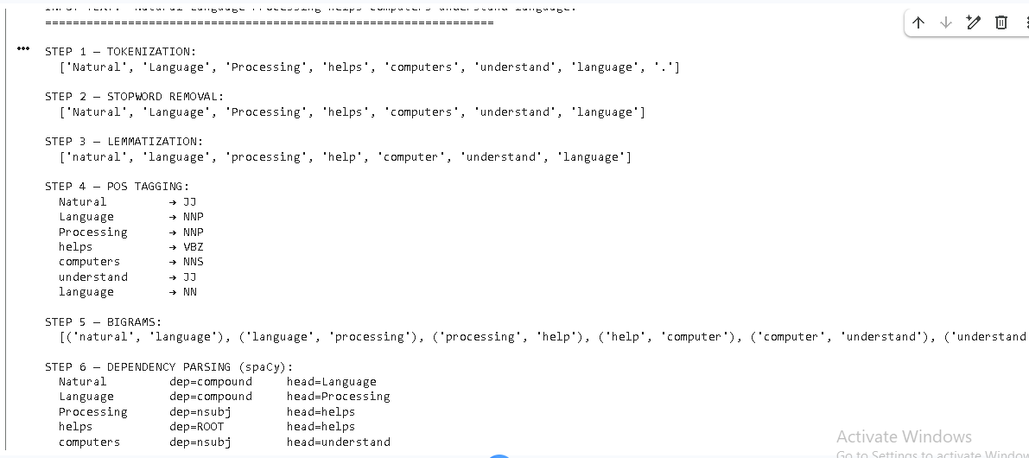
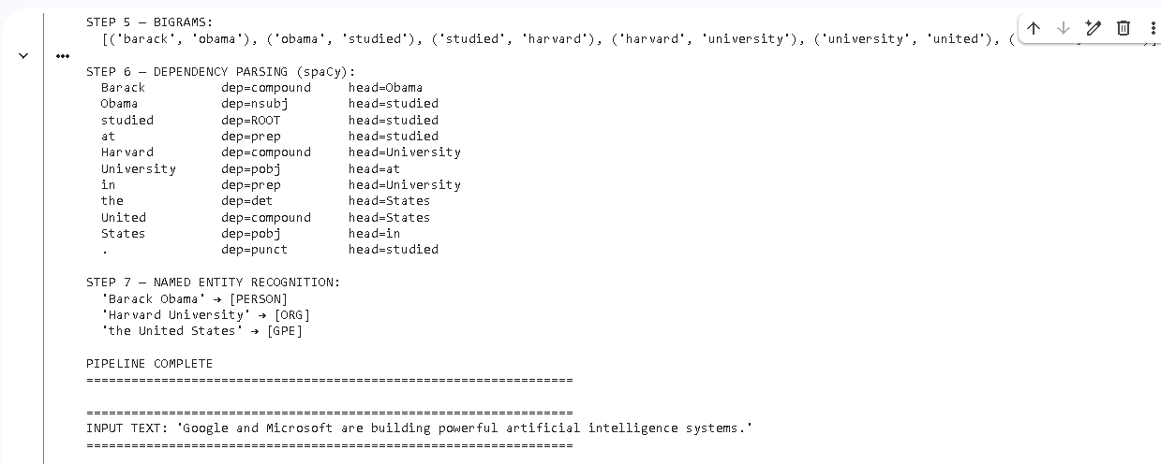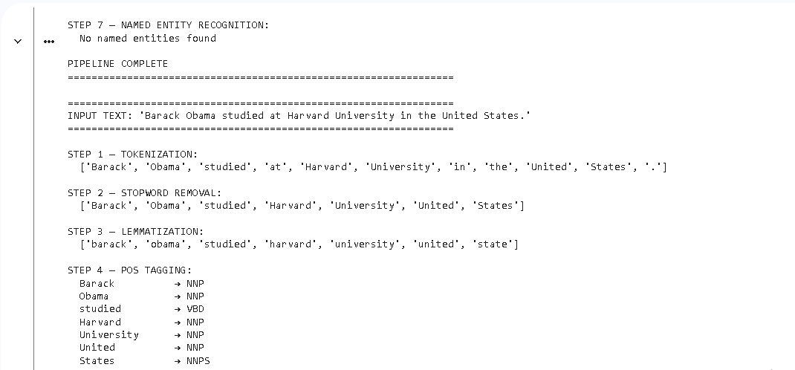

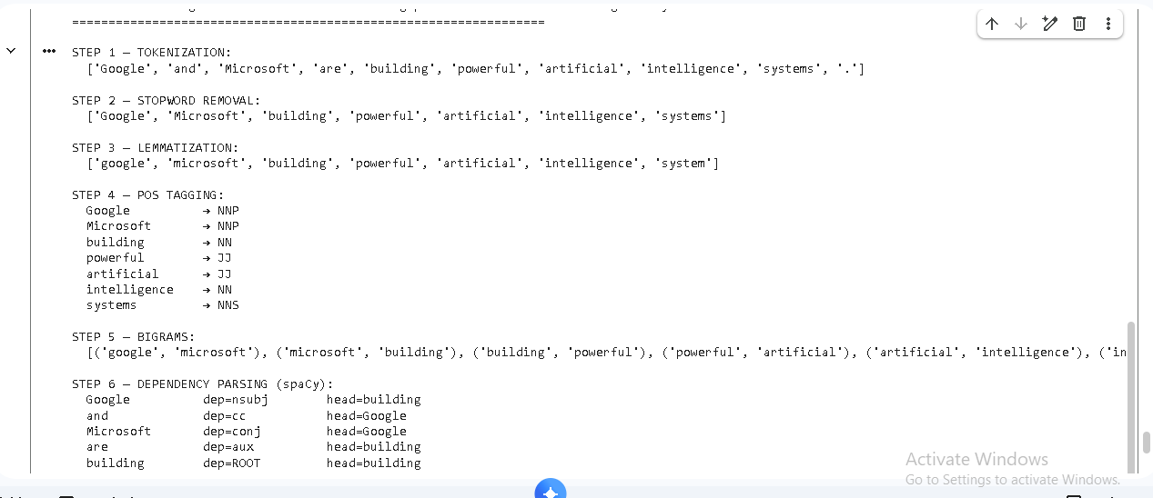

Fig 1- Complete NLP Pipeline Output

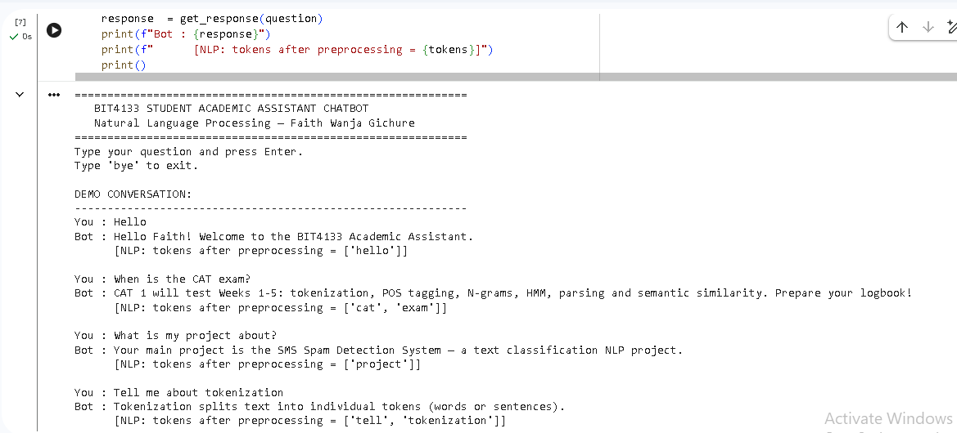

Fig 2 & 3- Chatbot Demo Conversation

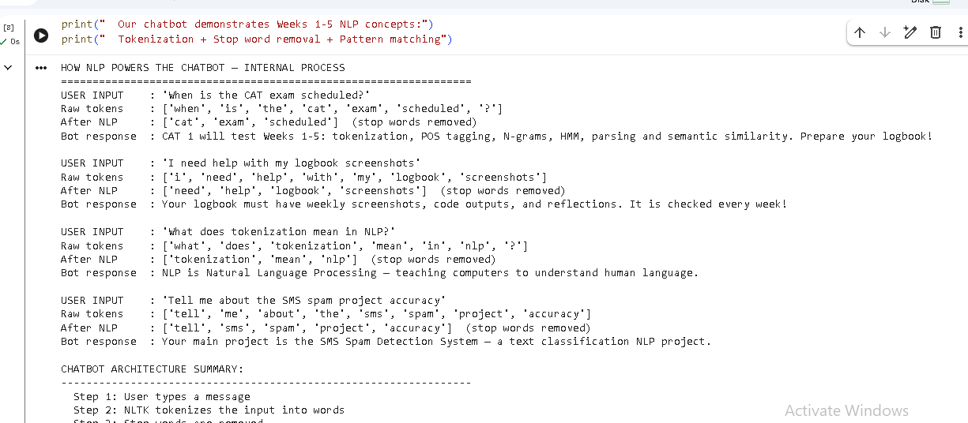

Fig 4- Chatbot Architecture Analysis

WEEK 5 REFLECTION
Week 5 was a full recap of all the NLP concepts learned in Weeks 1-4 via two major deliverables. In Practical Task 1, a full NLP pipeline of seven steps, namely tokenization, stop word removal, lemmatization, part-of-speech (POS) tagging, N-grams, dependency parsing and named entity recognition (NER), was developed and applied to three different sentences to demonstrate how text is progressively transformed at each stage. The mini project was a rule-based Student Academic Assistant Chatbot that matches user questions to predefined responses using NLTK tokenization and stop word removal. The chatbot could accept greetings, questions about CAT, questions about the logbook and explanations of NLP concepts.

